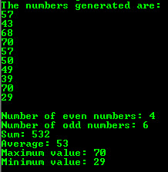**Fun with Numbers**

You are required to write a Java application program that will generate and display 10 random positive integer numbers in the range 20 to 70 (inclusive).

In addition, your program should report on how many of the numbers generated are odd, how many of the numbers generated are even, the sum of the numbers generated, the average of the numbers generated, the minimum value of the numbers generated and the maximum value of the numbers generated.

